Will-South Cook Soil and Water Conservation District Erosion Control Benefits Everyone

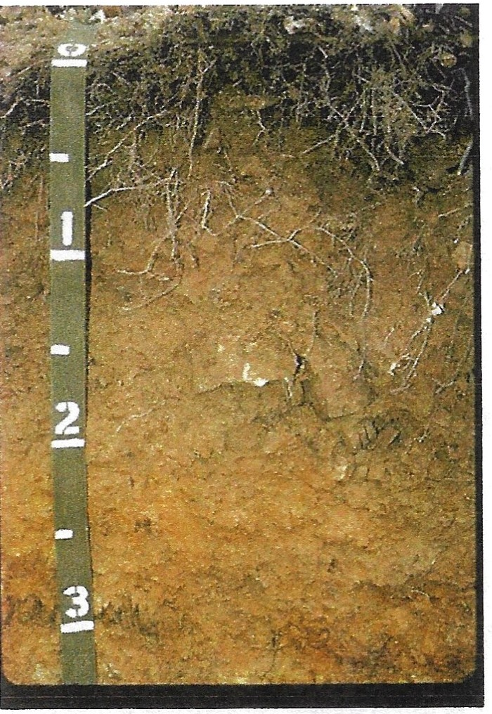
What's Below Your Feet?

A Soil Pit May Provide The Answer.
Spend morning learning while a Soil Scientist describes What We Seldom See. Listen about the Soil and Yield Benefits from Planting Cover Crops by Ken Krapf. He will have his modified planter at the field, share his soil test results and you'll see other practices.

Stacey Zuber - NRCS Soil Health Specialist and
Mark Bramstedt - Soil Scientist, will be speaking at this event

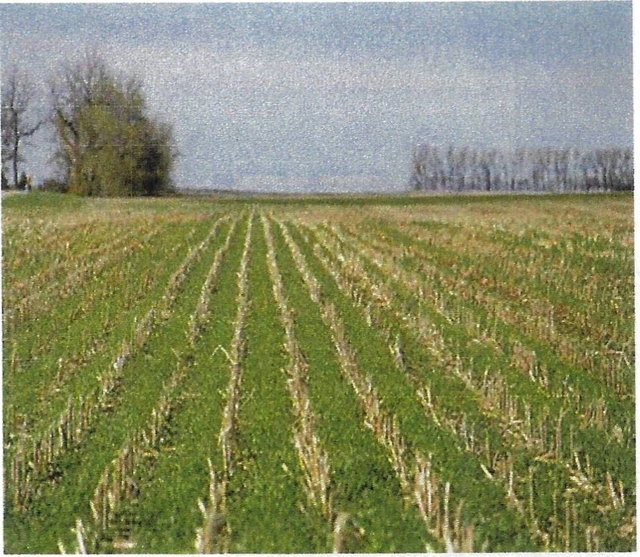
June 8th 9:30am - Noon Lunch Will Be Provided Free Event Please RSVP to 815 462-3106 X 3
info@will-scookswcd.org

Field farmed by Ken Krapf - located on Cedar Road 1 mile south of Manhattan Monee Rd., turn east on W. Bruns Road, approx. 1/4-mile east Lat: 41.41004 N, Lon: 87 .95679W

